Source https://www.viator.com/tours/Santiago/Coast-Tour-of-Valparaiso-Port-and-Vina-del-Mar-from-Santiago/d713-20268P5
__________________________________________________________

Santiago Coastal Escape: Valparaíso, Viña del Mar & Casablanca Wine Tasting
__________________________________________________________
★★★★★ 4.5/5 20 reviews

Add to wishlist ♡

__________________________________________________________

10 Hours | €100 per person

🏕  Image | 🏕  Image | 🏕  Image | 🏕  Image | 🏕  Image | 🏕  Image

__________________________________________________________
Experience Overview
Swap the city for Chile’s coastline on a full-day guided adventure from Santiago to two of the country’s most iconic seaside destinations: Valparaíso and Viña del Mar. Ride through scenic countryside, pause in the celebrated Casablanca Valley for a wine tasting, then spend your day discovering mural-filled hills, historic funiculars, elegant promenades, and ocean views. It’s the perfect mix of culture, coastal scenery, and local flavor — all in one well-paced day trip.
__________________________________________________________
Tour Snapshot
- Duration: Approx. 10 hours
- Meeting Point: Pickup from most centrally located Santiago hotels or Airbnb locations (share your address to confirm pickup time). If your hotel isn’t eligible, you’ll be given the nearest meeting point. Airport pickup may be available on request and costs $15 per person.
- Group Size: Small group (max 15 travelers; minimum 2 to operate)
- Accommodation: Not included (day tour experience)
- Languages Available: English, Spanish, Portuguese
- Private Guide: Not included (shared guided tour)
- Transportation: Included (comfortable coach/van with round-trip travel)
- Season: Available year-round
__________________________________________________________

Check Dates & Availability

Select participants: (Age 99 and younger) - 1 +

Choose date:
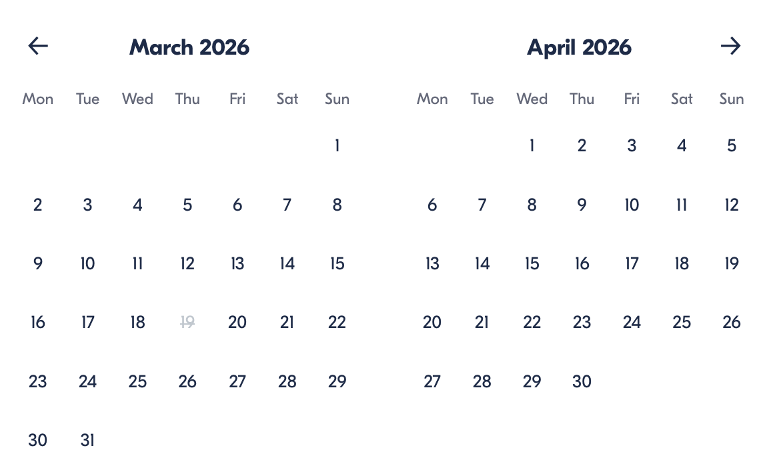

Check Availability

opens:

Participants: 1 March 16, 2026

Santiago Coastal Escape: Valparaíso, Viña del Mar & Casablanca Wine Tasting

- Duration: 10 hours
- Offered in: English / Spanish / Portuguese
- Starts at: 8:00 AM

Cancellation:

- More than 24 hours before start: Full refund
- Less than 24 hours before start: No refund

Price breakdown: 1 Participant x €100

Total: €100

The total price includes all taxes and fees.

Add to cart Book now

__________________________________________________________
Tour Highlights
- Casablanca Valley Wine Tasting: Stop in one of Chile’s best-known wine regions for a guided tasting.
- Viña del Mar Coastline: Enjoy seaside scenery along Avenida Perú and admire the city’s coastal charm.
- Easter Island Moai: See an authentic Moai statue displayed at the Fonck Museum area with guided context.
- Flower Clock: Visit Viña’s famous Reloj de Flores — one of the city’s signature photo stops.
- Sea Lions & Fish Market: Feel the energy of Caleta Portales, where you can spot sea lions near the market.
- Valparaíso Street Art & Hills: Walk through colorful lanes packed with murals, history, and character.
- Historic Funicular Ride: Take a classic Valparaíso elevator up the hillside for panoramic views.
__________________________________________________________
Detailed Itinerary

Day 1 – Valparaíso & Viña del Mar Coastal Journey (with Casablanca Wine Tasting)
Your day begins with a comfortable pickup in Santiago before heading out through Chile’s countryside toward the Pacific coast.
In Viña del Mar, take in the oceanfront atmosphere along Avenida Perú, with views across the coastline and toward Cerro Castillo. Continue to the area of the Fonck Museum to see a genuine Moai statue brought from Easter Island, followed by a stop at the iconic Flower Clock (Reloj de Flores) — a classic Viña landmark framed by vibrant gardens. You’ll also visit Caleta Portales, where the fish market buzzes with local life and sea lions often lounge near the shore.
Next, it’s on to Valparaíso, Chile’s artistic port city known for its steep hills and bold street art. Explore the civic heart of the city at Plaza Sotomayor, home to the Navy headquarters and the Monument to the Heroes of the Pacific War. Ride the historic Ascensor El Peral funicular for sweeping city views, then visit Palacio Baburizza, a striking mansion-turned-art museum perched above the harbor. Stroll scenic viewpoints such as Paseo Yugoeslavo, and wander lanes like Pasaje Bavestrello and the mural-filled areas around Gálvez and Cerro Concepción, where Victorian and German-influenced architecture mixes with creative cafes and boutiques.
To finish, you’ll stop in the renowned Casablanca Valley for a wine tasting at a local winery — a relaxing finale before the comfortable return ride to Santiago.
Accommodation:
Not included (day tour experience)
__________________________________________________________
Included in Price
- Hotel pickup and drop-off in Santiago (where available)
- Drop-off at Valparaíso port (for cruise ship travelers)
- Wine tasting in Casablanca Valley
- One funicular ride in Valparaíso
- Alcoholic beverages (as part of the experience inclusions)
- Luggage allowance for cruise travelers: 1 large suitcase + 1 carry-on (no extra charge)
__________________________________________________________
Not Included
- Lunch
- Gratuities
__________________________________________________________
Not Suitable For
- Wheelchair users
__________________________________________________________
Important Trip Info
- Pickup & confirmation: Share your Santiago location to confirm pickup time. If your hotel/Airbnb isn’t eligible, the supplier will assign the nearest meeting point.
- Airport pickup: Only available upon request and costs $15 per person (if available).
- Cruise luggage rules: If requesting port drop-off, you must report how many bags you have — otherwise, luggage transport may not be possible.
- Winery stop note: If you choosethe Valparaíso drop-off, you will miss the Casablanca winery visit, since it’s done on the return to Santiago.
- Luggage limits: Max per person is 1 large carry-on; extra luggage may require an additional fee.
- Tour requirements: Minimum 2 guests to operate; maximum 15 travelers. If the minimum isn’t met, you’ll be offered an alternative or a full refund.
__________________________________________________________

Cancellation Policy
Cancel at least 24 hours before the start time for a full refund.
- Cancellations within 24 hours are non-refundable.
- Changes within 24 hours are not accepted.
If the experience is canceled because the minimum number of travelers isn’t met, you’ll be offered an alternative date/experience or a full refund.
__________________________________________________________
What Our Clients Are Saying

Overall rating  4.5/5  ★★★★★  Based on 20 reviews | Review summary  Guide 4.5/5  Transportation 4.6/5  Service 4.7/5  Organisation 4.5/5

Filter  - All traveller types  - Couples  - Group of friends  - Families  By star rating  - All star ratings  - 5 stars  - 4 stars  - 3 stars  - 2 stars  - 1 star | Search reviews (e.g., guide)  Sort by:  - Top picks  - Latest reviews  - Best ratings  - Lowest ratings
__________________________________________________________
★★★★★
Elisa R. — Italy
Such a beautiful mix of coast, culture, and color. Valparaíso’s street art and viewpoints were unforgettable, and the wine tasting was a perfect finish.
★★★★☆
Miguel A. — Spain
Great itinerary and a very smooth day overall. Some stops felt a little quick, but we saw a lot, and the guide made everything easy to follow.
★★★★★
Camila N. — Brazil
One of my favorite days in Chile. Viña del Mar was gorgeous, Valparaíso was full of personality, and the Casablanca tasting was the cherry on top.

See more reviews
__________________________________________________________

Meta tags

Page - Santiago Coastal Escape: Valparaíso, Viña del Mar & Casablanca Wine Tasting

Title: Santiago Coastal Escape: Valparaíso, Viña del Mar & Casablanca Wine Tasting | Travellio Global

Description: Discover Chile’s coastal icons in one day — explore Viña del Mar’s seaside landmarks, wander Valparaíso’s colorful hills and street art, and enjoy a Casablanca Valley wine tasting, with convenient Santiago pickup.

H1 - Santiago Coastal Escape: Valparaíso, Viña del Mar & Casablanca Wine Tasting
__________________________________________________________

